Symbols and abbreviations

Symbol |  | Units
a | Plant absorption flux | m s-1
ASW | Plant available soil water | m
b | Texture dependent soil conductivity parameter
C | Plant capacitance | m MPa⁻¹
C_{c} | Coefficient of transpiration fraction of Eat
Cp | Specific heat of air | °K
C_{s} | Coefficient of evaporation fraction of Eat
d | Depth of root zone soil layer | m
FC | Volumetric soil water content at field capacity | m³ m⁻³
E_{at} | Total evapotranspiration | m
E_{k} | Evaporation from a soil layer | m
E_{i} | Evaporation from canopy | m
E_{s} | Soil surface evaporation | m
E_{t} | Plant transpiration | m
G | Soil surface heat flux | W m⁻²
K_{s} | Soil hydraulic conductivity | m s-1
kl | Root density parameter
LAI | Leaf area index | m² m⁻²
P_{input} | Precipitation reaching the soil surface | m
P_{total} | Total precipitation | m
q | Storage/destorage flux | m s⁻¹
r_{a} | Aerodynamic resistance | m s⁻¹
r_{bH2O} | Boundary layer resistance to water vapour exchange | m s⁻¹
r_{stoH2O} | Stomatal resistance to water vapour exchange | m ^{s-1}
r_{inc} | In canopy resistance | m ^{s-1}
r_{p} | Plant hydraulic resistance | MPa (m s⁻¹)⁻¹
r_{sp} | Soil-plant hydraulic resistance | MPa (m s⁻¹)⁻¹
r_{sr} | Soil-root hydraulic resistance | MPa (m s⁻¹)⁻¹
R_{n} | Net radiation at top of canopy | W m⁻²
R_{ns} | Net radiation at soil surface | W m⁻²
Rd_{k} | Root zone depth | m
Rf_{k} | Root fraction with soil depth
S_{c} | Canopy storage capacity | m
VPD | Vapour pressure deficit or air | MPa
β | Root fraction parameter
Δ | Slope of the relationship between saturation vapour pressure and temperature | MPa °K⁻¹
γ | Psychrometric constant | MPa °K⁻¹
λ | Latent heat of vaporisation | °K
ρ_{a} | Air density | Kg m⁻³
θ | Volumetric soil water content | m³ m⁻³
θ_{sat} | Volumetric soil water content at saturation | m³ m⁻³
Ψ_{e} | Soil water potential at air entry | MPa
Ψ_{leaf} | Leaf water potential | MPa
Ψ_{sat} | Soil water potential at saturataion | MPa
Ψ_{soil} | Soil water potential | MPa
Ψ_{r} | Water potential of plant reservoir | MPa

Soil water balance

The DO₃SE soil moisture module is based on the Penman-Monteith model of evapotranspiration. As such, soil water loss is driven by evaporative demand limited by a series of soil-plant-atmosphere resistances to water loss. A simple mass balance calculation is used to estimate the soil water balance over a finite depth of soil determined by a species-specific maximum root depth (Rd) as a function of incoming precipitation and outgoing total evapotranspiration (E_{at}) calculated as a function of plant transpiration (E_{t}) and soil evaporation (E_{s}).

Hourly E_{t,} E_{s} and E_{i} are calculated using the Penman-Monteith model (Monteith, 1965). To estimate E_{t} , E_{s} and E_{i}, only those resistances (i.e. r_{a} and r_{bH2O}) that occur between the top of the evaporative surface and the measurement height of VPD need to be included. Since we assume that VPD is provided at the external margin of the canopy boundary layer only r_{bH2O} and r_{inc} would be required as appropriate. The following formulation describes the Penman-Monteith model for E_{t}.

E_{t} = 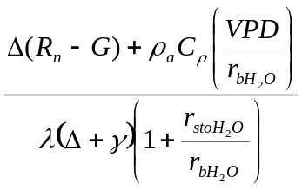

Where Δ is the slope of the relationship between the saturation vapour pressure and temperature, Rn is the net radiation above the canopy, G is the soil heat flux, ρ_{a} is the air density, Cρ is the specific heat of air, R_{bH2O} is the boundary layer resistance to water vapour exchange, r_{stoH2O} is the stomatal canopy resistance to transfer of water vapour, γ is the psychometric constant λ is the latent heat of vaporization.

When the forest canopy is incomplete (i.e. LAI < 1) and soil moisture is less than FC (θ = FC), the soil will lose moisture though evaporation from the soil surface (E_{s}) at a rate defined by the Penman-Monteith equation for evaporation modified to include the resistances from the soil surface to the atmosphere. [Juha Pekka - is the use of the Rinc for ozone appropriate here???]

E_{s} = 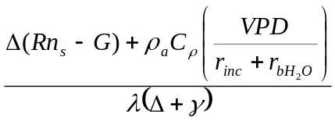

Where Rn_{s} is the net radiation available at the soil surface beneath the canopy, estimated by

Rn_{s} = τR_{n}

τ = exp(-K_{a}*LAI)

Where K_{a} is the coefficient for attenuation of available energy and is set to 0.5 for consistency with the DO₃SE module used to estimate canopy radiation penetration.

The total loss of soil water through E_{at} when the tree canopy has an LAI <1 is calculated using the method of Shuttleworth & Wallace (1985) modified to incorporated resistance terms calculated with DO₃SE.

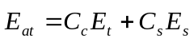

Where
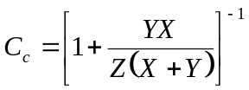

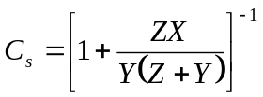

and
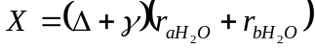
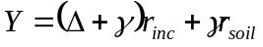
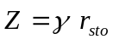

[Juha Pekka…any chance you could check these equations]

Daily recharge of soil water by P_{input} is calculated according to total precipitation (P_{total}), from which a fraction is lost through interception by the canopy and subsequent evaporation (E_{i}). The amount that can be intercepted by the canopy is determined by the external storage capacity of the canopy, (S_{c}, mm) which is set at 0.1 * LAI using the methodology of the Revised Simple Biosphere Model (SIB-2) (Sellers et al., 1996) which was developed for a range of land cover types including broadleaf and needleleaf trees.

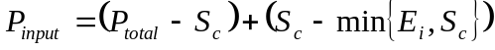

Here the fraction of intercepted P_{total} that might ultimately reach the soil is dependent upon Ei, which is estimated using the Penman equation for evaporation from a wet surface (Monteith, 1965).

E_{i} = 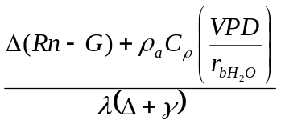 [x]

At the start of the year, when soil water calculations are initialized, volumetric root zone soil water (θ) is assumed to be equal to field capacity (FC) hence soil water storage (S_{n}) is assumed to be at a maximum. The volumetric FC defines the relative amount of water held by capillarity against drainage by gravity and is dependent on soil texture (Foth, 1984).

Daily estimations of S_{n} are made according to the mass balance formulation based on those used by Mintz & Walker (1993) where the S_{n} changes on a daily time step according the equation.

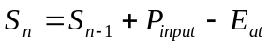

Where S_{n-1} is the soil water content of the previous day, E_{at} is the total water loss to evapotranspiration and P_{input} is water gained via precipitation; any excess P_{input} is assumed to be lost to run-off or percolation from the rooting zone. Volumetric water content (θ) over the rooting zone is calculated as Sn/Rd. The physiologically relevant soil water potential (Ψ_{soil}) is then estimated fromθ using standard soil water characterization curves as defined by Campbell (1985) and empirical parameters Ψ_{e}, θ_{sat} and b are based on Tuzet et al. (2003) as described in Table 1.

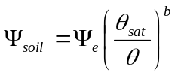

In order for the parameterisation of the DO₃SE model to be applicable across Europe, soil water characteristic curves were defined for 4 representative soil textures: sandy loam, silt loam, loam and clay loam.

Stomatal conductance
The calculation of hourly stomatal conductance uses an estimate of leaf water potential (Ψ_{leaf}) described by Lhomme et al. (2001), who modify the resistance-based method of Jones (1978) by including resistance and capacitance terms for a plant water reservoir. It is assumed that pre-dawn Ψ_{leaf} is equilibrated with Ψ_{soil} and decouples as the day progresses (Fitter & Hay, 2002).

Total plant transpiration (Et) is divided into absorption flux (a), defined as the water absorbed from the soil into the plant and storage/de-storage flux (q), the flux of water in and out of the plant reservoir.

The absorption flux is expressed as the difference in potential between Ψ_{leaf} and Ψ_{soil}

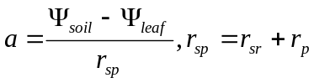

Where the soil-plant hydraulic resistance (r_{sp}) is the sum of soil-root resistance (r_{sr}) and plant resistance (r_{p}). Root distribution is assumed to be homogenous through each soil layer; xylem resistance due to drought induced embolism is not included in this scheme.

The resistance to the uptake of water from the soil to the roots is accounted for in the soil-resistance term (r_{sr}) after Lhomme et al. (2001)

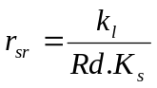

Where k_{l} is a constant related to root density = 3.5x10⁻¹², K_{s} (m s⁻¹) is the soil hydraulic conductivity estimated according to standard principles (e.g. Jones, 1992) according to

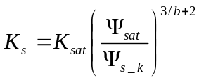

To ensure internal consistency, K_{sat}, b and Ψ_{sat} are defined using the soil texture specific, empirically derived parameters (Tuzet at al., 2003) described in Table 1.

Changes in leaf water potential are calculated as a function of E_{t} (mm h⁻¹), Ψ_{soil} (assumed to be equal to pre-dawn Ψ_{leaf}), r_{sr}, C, r_{c} and r_{p} (entered as empirically derived constants, see Table 1), where C is the plant capacitance (C, mm MPa⁻¹).
We assume that Ψ_{leaf} equilibrates with Ψ_{soil} overnight and at the start each day the equation is initialised at t=0 as Ψ_{leaf}=Ψ_{soil}. The physiologically relevant pre-dawn Ψ_{soil} is calculated for each day using the bulk change in soil water over the entire rooting zone based on Et. Changes in Ψ_{leaf} are calculated as below and for each hour.

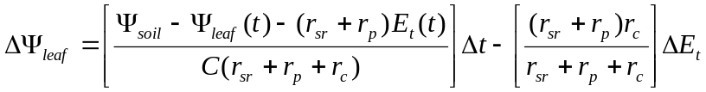

Ψ_{leaf}(t) = Ψ_{leaf}(t-1)+ΔΨ_{leaf}

To incorporate xylem hydraulic conductivity into the estimate of stomatal conductance, we assume that Ψ_{leaf} limits g_{sto} according to a relationship between relative g_{sto} and pre-dawn Ψ_{leaf}. This relationship has been defined by fitting a power regression equation to observations of pre-dawn Ψ_{leaf} and relative g_{max} (Figure 2). Since the data indicate variable tolerance to pre-dawn Ψ_{leaf} for boreal/temperate and Mediterranean species we have defined different f_{wp} relationships for these two forest types. It is assumed that g_{sto} is increasingly limited until f_{min} is reached.

Boreal/temperate forest trees:
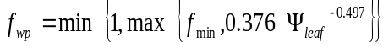

Mediterranean forest trees:

Tim to include relationship

The observations of pre-dawn Ψ_{leaf} and relative g_{max} for boreal/temperate forest trees were collated from pre-dawn Ψ_{leaf} data for beech (Fagus sylvatica), temperate oak (Quercus robur and Quercus petraea), Scots pine (Pinus sylvestrus), Norway spruce (Picea albes) and for Mediterranean forest trees from holm oak (Quercus ilex) all from published literature. Because f_{WP} relationships for boreal/temperate coniferous and deciduous trees are very similar we use a generic f_{WP} relationship for northern and central Europe derived using combined data for both tree types.

A post-hoc method can be used to provide an indication of the variability in soil moisture with soil depth, assuming this is driven by root density. Modelling methods will tend to assume two extreme cases, one where roots are distributed homogenously throughout the rooting depth and others where root distribution follows an exponential profile with most roots in the upper soil layers. Here we show the soil water variables according to both these assumptions.

The exponential root distribution influence on soil water is achieved using estimates of root fraction based on the empirical observations of Baker et al (1996), who defined an exponential decrease in cumulative root fraction for a generic tree, based on published values for temperate and boreal trees in Europe. The root fraction present in a soil layer (RD_{k}) can be presented as described in the equations below, this is then used to weight the bulk soil layer water contents according to the depth of the soil variable measurements being investigated.

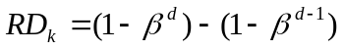

d = soil layer depth
β = empirically derived parameter, 0.97

References

Fitter, A.H. & Hay, R.K.M. (2002) Environmental physiology of plants. 3rd edition. Academic Press.

